OCIMF Publishes Recommendations on Usage of ECDIS and Preventing Incidents

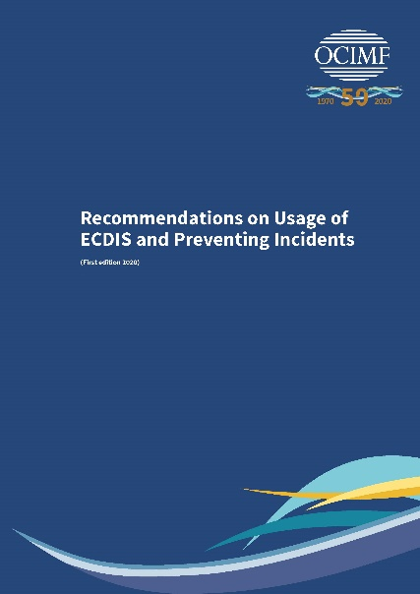
11 November 2020 – (LONDON) The Oil Companies International Marine Forum (OCIMF) has released a new information paper today, Recommendations on Usage of ECDIS and Preventing Incidents, which provides guidance to enhance policies and procedures regarding the safe use of Electronic Chart Display and Information Systems (ECDIS).

With more vessels using Electronic Navigational Charts (ENCs) for primary or secondary navigation, there have been several significant navigational incidents over the last decade where one of the contributing factors has been ECDIS-related. Recommendations on Usage of ECDIS and Preventing Incidents takes into account ECDIS-related navigational incident findings and safety-related observations from OCIMF’s Ship Inspection Report Programme (SIRE). To provide practical support and guidance, the information paper draws upon this analysis to provide recommendations for improving ECDIS-related practices and preventing ECDIS-related navigational incidents.

OCIMF Managing Director, Robert Drysdale commented, “My view is that technology and digitalisation provide tools to ensure our industry will be successful and sustainable in the future. However, new technology can introduce unintended consequences if not planned, developed and introduced in a robust manner. Everyone recognises the benefits that ECDIS brings, but we have witnessed incidents caused through the misuse or misunderstanding of the technology. If followed, the recommendations contained in this information paper will help drive down the number of incidents associated with the use of ECDIS. I encourage all those who use ECDIS to read it and apply the recommendations.”

The information paper, which is available to download for free from OCIMF.org, is aimed at ship owners, operators, Masters, Navigating Officers and bridge team members including pilots as well as ECDIS system manufacturers. Key chapters in the information paper cover ECDIS carriage requirements, ECDIS training and familiarisation, passage planning and alarm management.

The information paper is available and free to download from www.ocimf.org.

-ends-

Notes to Editor
- The Oil Companies International Marine Forum (OCIMF) is a voluntary association of oil companies with an interest in the shipment and terminalling of crude oil, oil products, petrochemicals and gas. OCIMF focuses exclusively on preventing harm to people and the environment by promoting best practice in the design, construction and operation of tankers, barges and offshore vessels and their interfaces with terminals.
Vision A global marine industry that causes no harm to people or the environment.
Mission To lead the global marine industry in the promotion of safe and environmentally responsible transportation of crude oil, oil products, petrochemicals and gas, and to drive the same values in the management of related offshore marine operations.
We do this by developing best practices in the design, construction and safe
operation of tankers, barges and offshore vessels and their interfaces with terminals and considering human factors in everything we do

- Cover image and Rob Drysdale photo available on request.
Enquiries For further information contact Kelly Hadley, Publishing and Communications Manager, OCIMF on 020 7654 1227 or kelly.hadley@ocimf.org.

